North Sunrise Little League Field Map

Handy Park
2143 E. Oakmont Avenue Orange, CA 92867

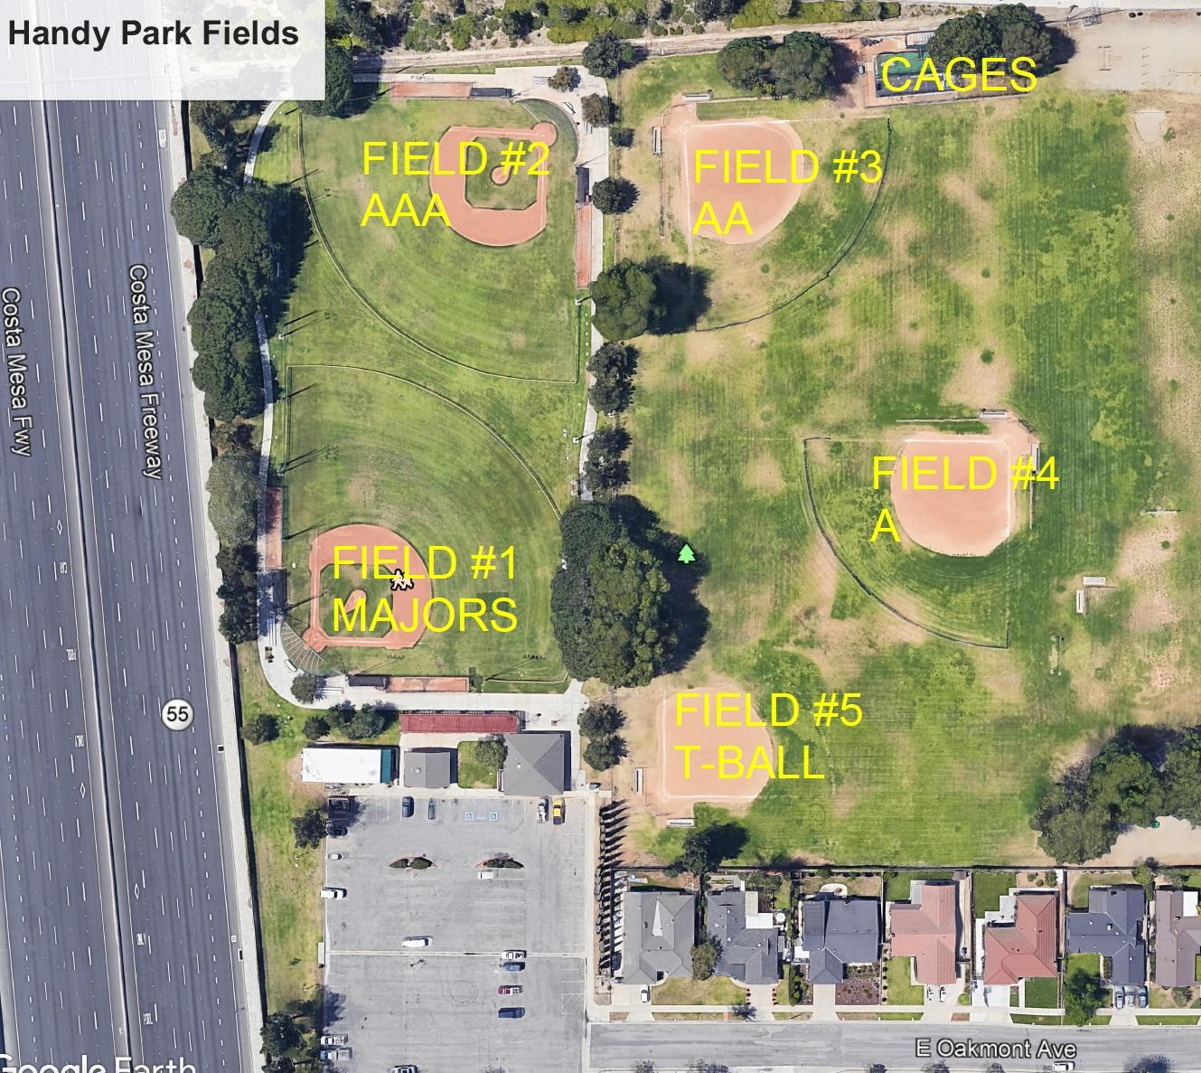

Tustin Eastern Little League Field Map

UTT Middle School
13601 Browning Ave Tustin, CA 92780
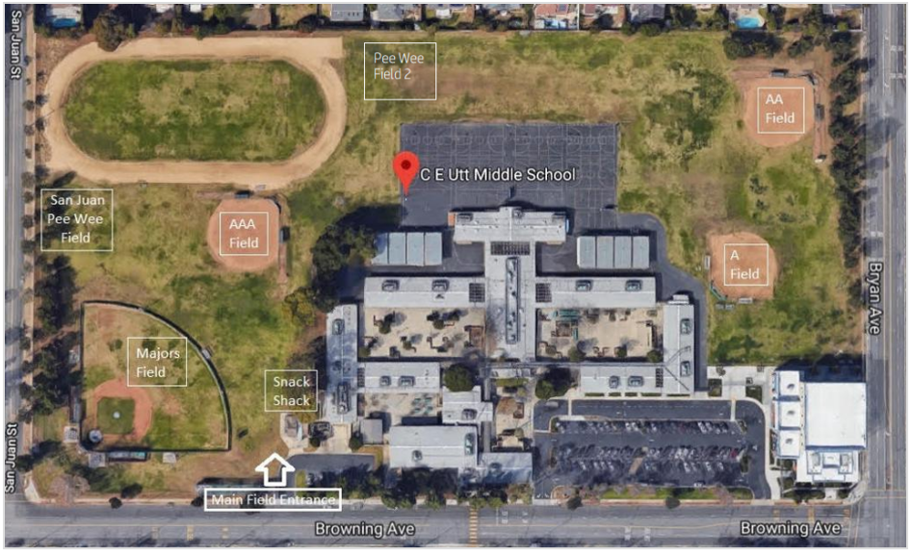

UTT Middle School – Field Locations
Phillips (Majors) Field | Corner of Browning and San Juan. The field with the lights!
AAA field | Field near snack shack behind the Majors field. This field is not lit.
AA field | Field in the far corner (farthest from parking lot) near Bryan
A field | Closest field near the corner of Bryan and Browning
Pee Wee Field | Pee Wee Field Behind Majors Field off of San Juan entrance

Anaheim Hills Little League Field Map

Peralta Canyon Park
115 N Pinney Drive Anaheim, CA 92807

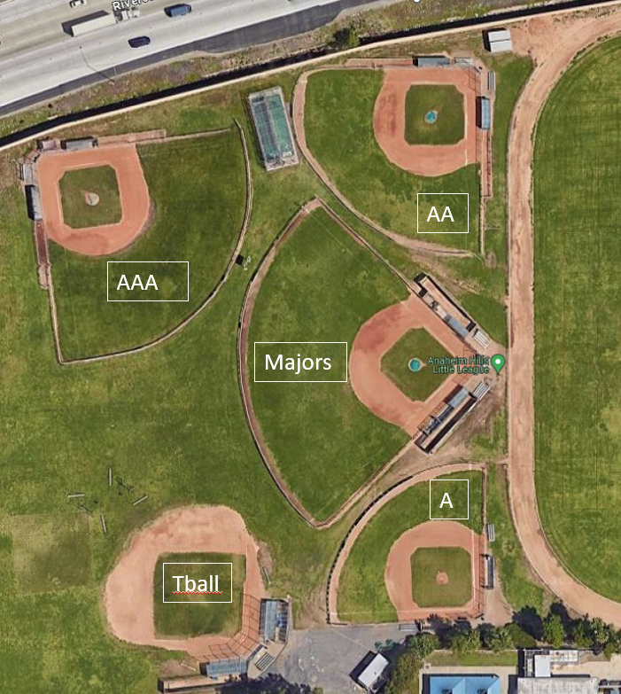

South Sunrise Little League Field Map

McPherson Magnet School
333 S Prospect St Orange, CA 92869

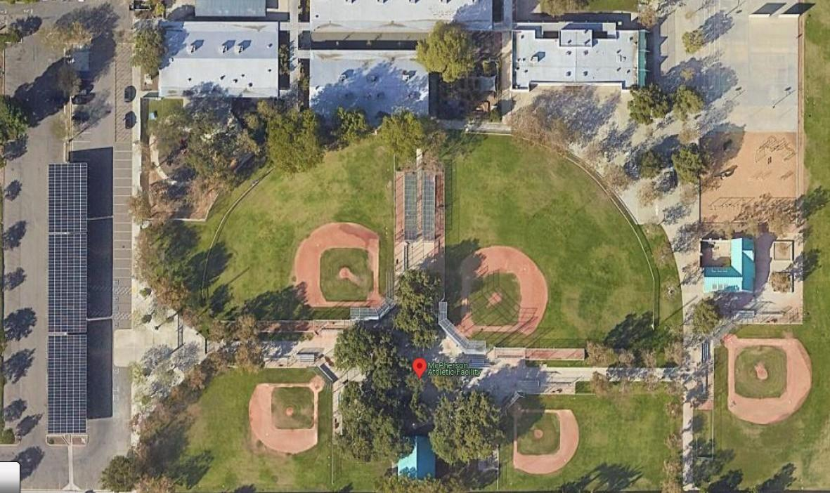
Field 1
Field 2
Field 1
Field 3
Field 4
Field 5

